**University of Engineering and Technology (New Campus),**

**Lahore**



# DBMS Lab

**Final Project**

**Project Name:**

**University Management System Database**

**Submitted By:**

**Ahtesham Ahsan (2020-CS-661)**

**Sheikh Hamza (2020-CS-673)** **Hassaan Ahmad (2020-CS-678)**

**Dawood Zahid (2020-CS-705)**

**Submitted To:**

**Sir Rehan**

**DATA DEFINITION LANGUAGE**

**CREATE COMMANDS**

**Create Command For Teacher Table:**

create table teacher(

Teach_id int,

first_name varchar(50),

last_name varchar(50),

phone_number bigint,

[state] varchar(30),

city varchar(30),

zip int,

date_of_birth date,

email_id varchar(50),

Teach_Dept varchar(50),

CNIC decimal(13,0),

Addres varchar(50),

primary key(teach_id)

);

**OUTPUT SCREENSHOT**

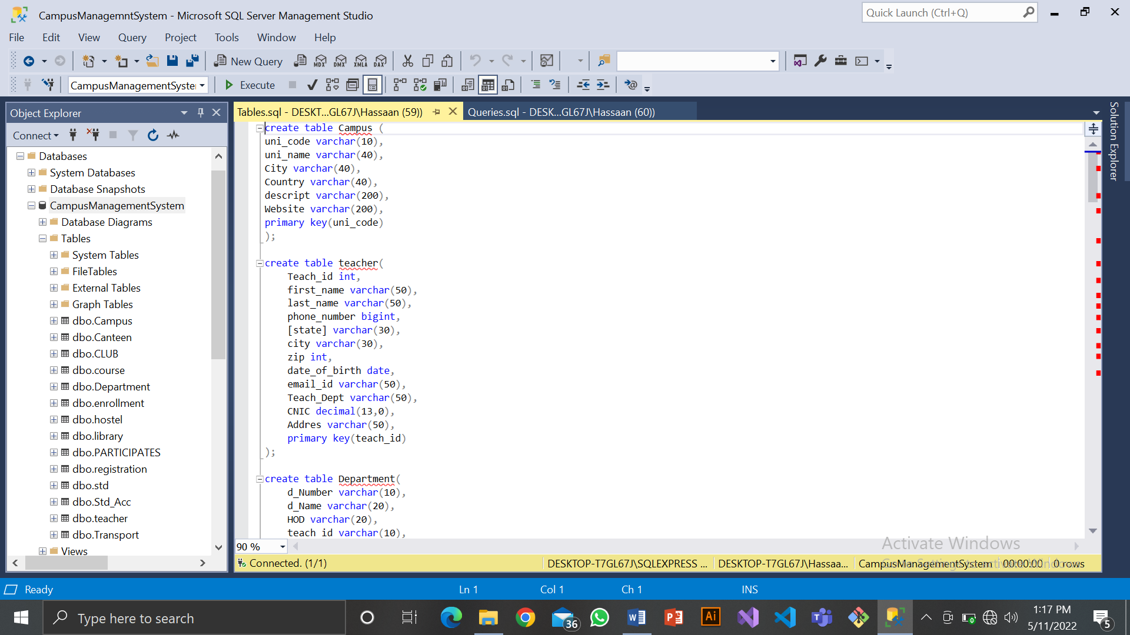

**Create Command For Student Table:**

create table std(

std_id varchar(10),

first_name VARCHAR(50),

last_name VARCHAR(50),

email VARCHAR(50),

gender VARCHAR(50),

SSN INT,

[state] VARCHAR(50),

city VARCHAR(50),

zip VARCHAR(50),

mobile_number BIGINT,

date_of_birth DATE,

GPA DECIMAL(3,2),

Dnumber varchar(10) NOT NULL,

PRIMARY KEY (std_id),

foreign key(Dnumber) references Department(d_Number)

);

**OUTPUT SCREENSHOT**

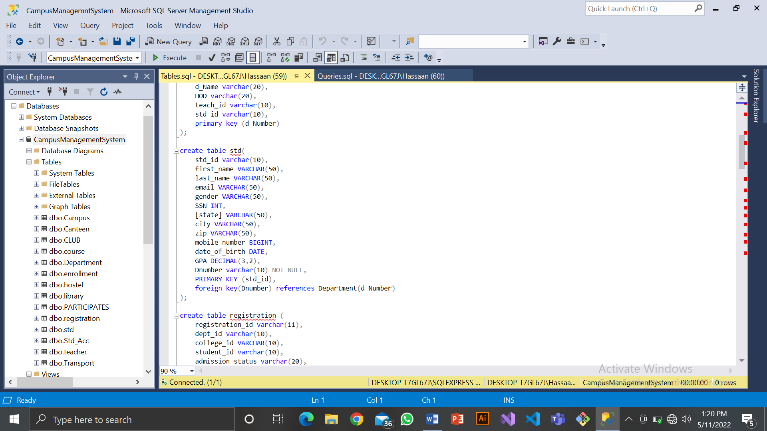

**Create Command For Registration Table:**

create table registration (

registration_id varchar(11),

dept_id varchar(10),

college_id VARCHAR(10),

student_id varchar(10),

admission_status varchar(20),

year_of_application varchar(10),

degree_type varchar(20),

PRIMARY KEY (registration_id),

FOREIGN KEY (college_id) REFERENCES Campus(uni_code),

FOREIGN KEY (student_id) REFERENCES Std(std_id),

Foreign Key (dept_id) REFERENCES DEPARTMENT(d_Number)

);**OUTPUT SCREENSHOT**

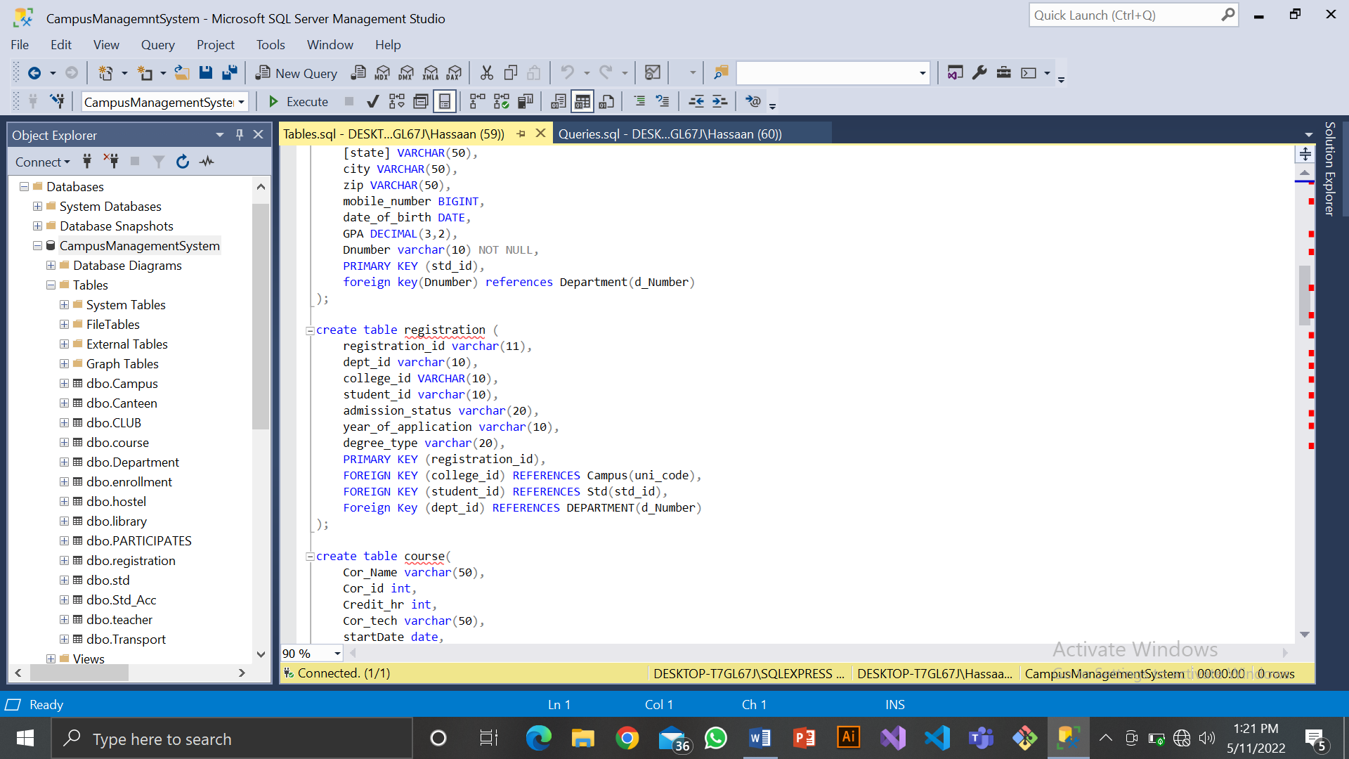

**Create Command For Course Table:**

create table course(

Cor_Name varchar(50),

Cor_id int,

Credit_hr int,

Cor_tech varchar(50),

startDate date,

endDate date,

primary key(Cor_id)

);**OUTPUT SCREENSHOT**

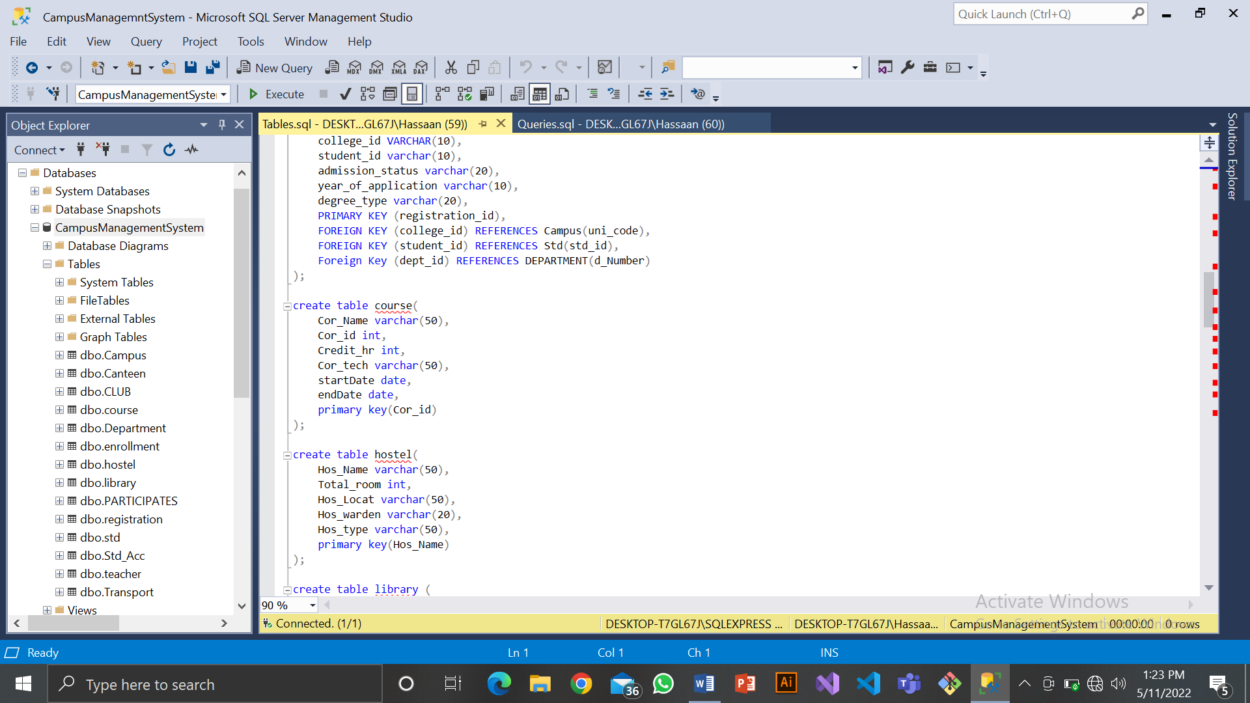

**Create Command For Hostel Table:**

create table hostel(

Hos_Name varchar(50),

Total_room int,

Hos_Locat varchar(50),

Hos_warden varchar(20),

Hos_type varchar(50),

primary key(Hos_Name)

);

**OUTPUT SCREENSHOT**



**Create Command For Library Table:**

create table library (

lib_branch int primary key not null,

lib_location varchar(50),

book_collection varchar(50)

);

**OUTPUT SCREENSHOT**

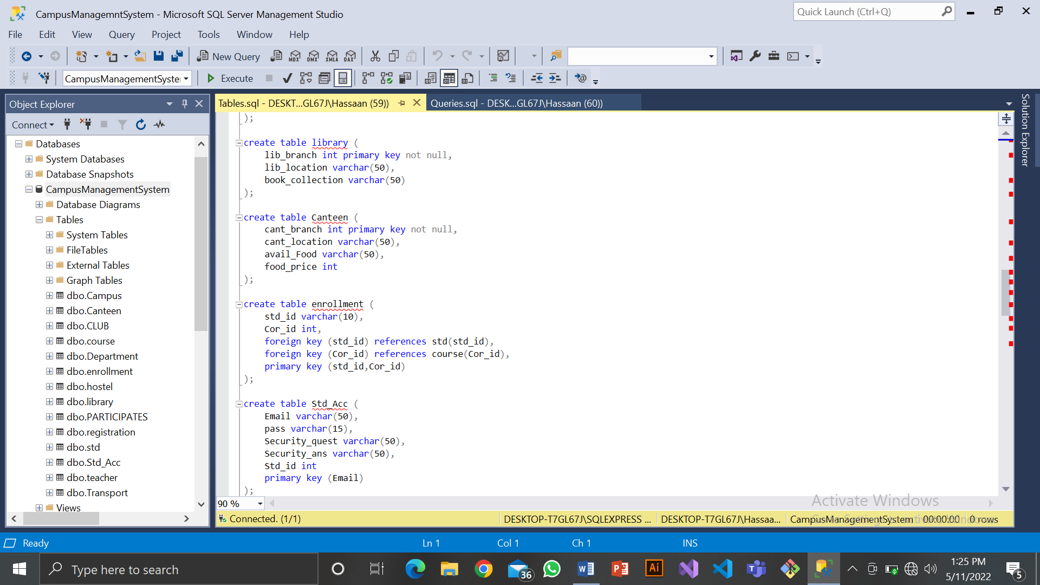

**Create Command For Canteen Table:**

create table Canteen (

cant_branch int primary key not null,

cant_location varchar(50),

avail_Food varchar(50),

food_price int

);

**OUTPUT SCREENSHOT**



**Create Command For Enrollment Table:**

create table enrollment (

std_id varchar(10),

Cor_id int,

foreign key (std_id) references std(std_id),

foreign key (Cor_id) references course(Cor_id),

primary key (std_id,Cor_id)

);

**OUTPUT SCREENSHOT**



**ALTER TABLE COMMANDS**

**Alter Table Command For Student Table**

* alter table std

add Bus_no varchar(10),

club_id varchar(10),

foreign key (club_id) references CLUB (club_id),

foreign key (Bus_no) references Transport (Bus_Num);

* alter table std

add Hos_Name varchar(50),

foreign key (Hos_Name) references hostel (Hos_Name);

**OUTPUT SCREENSHOT**

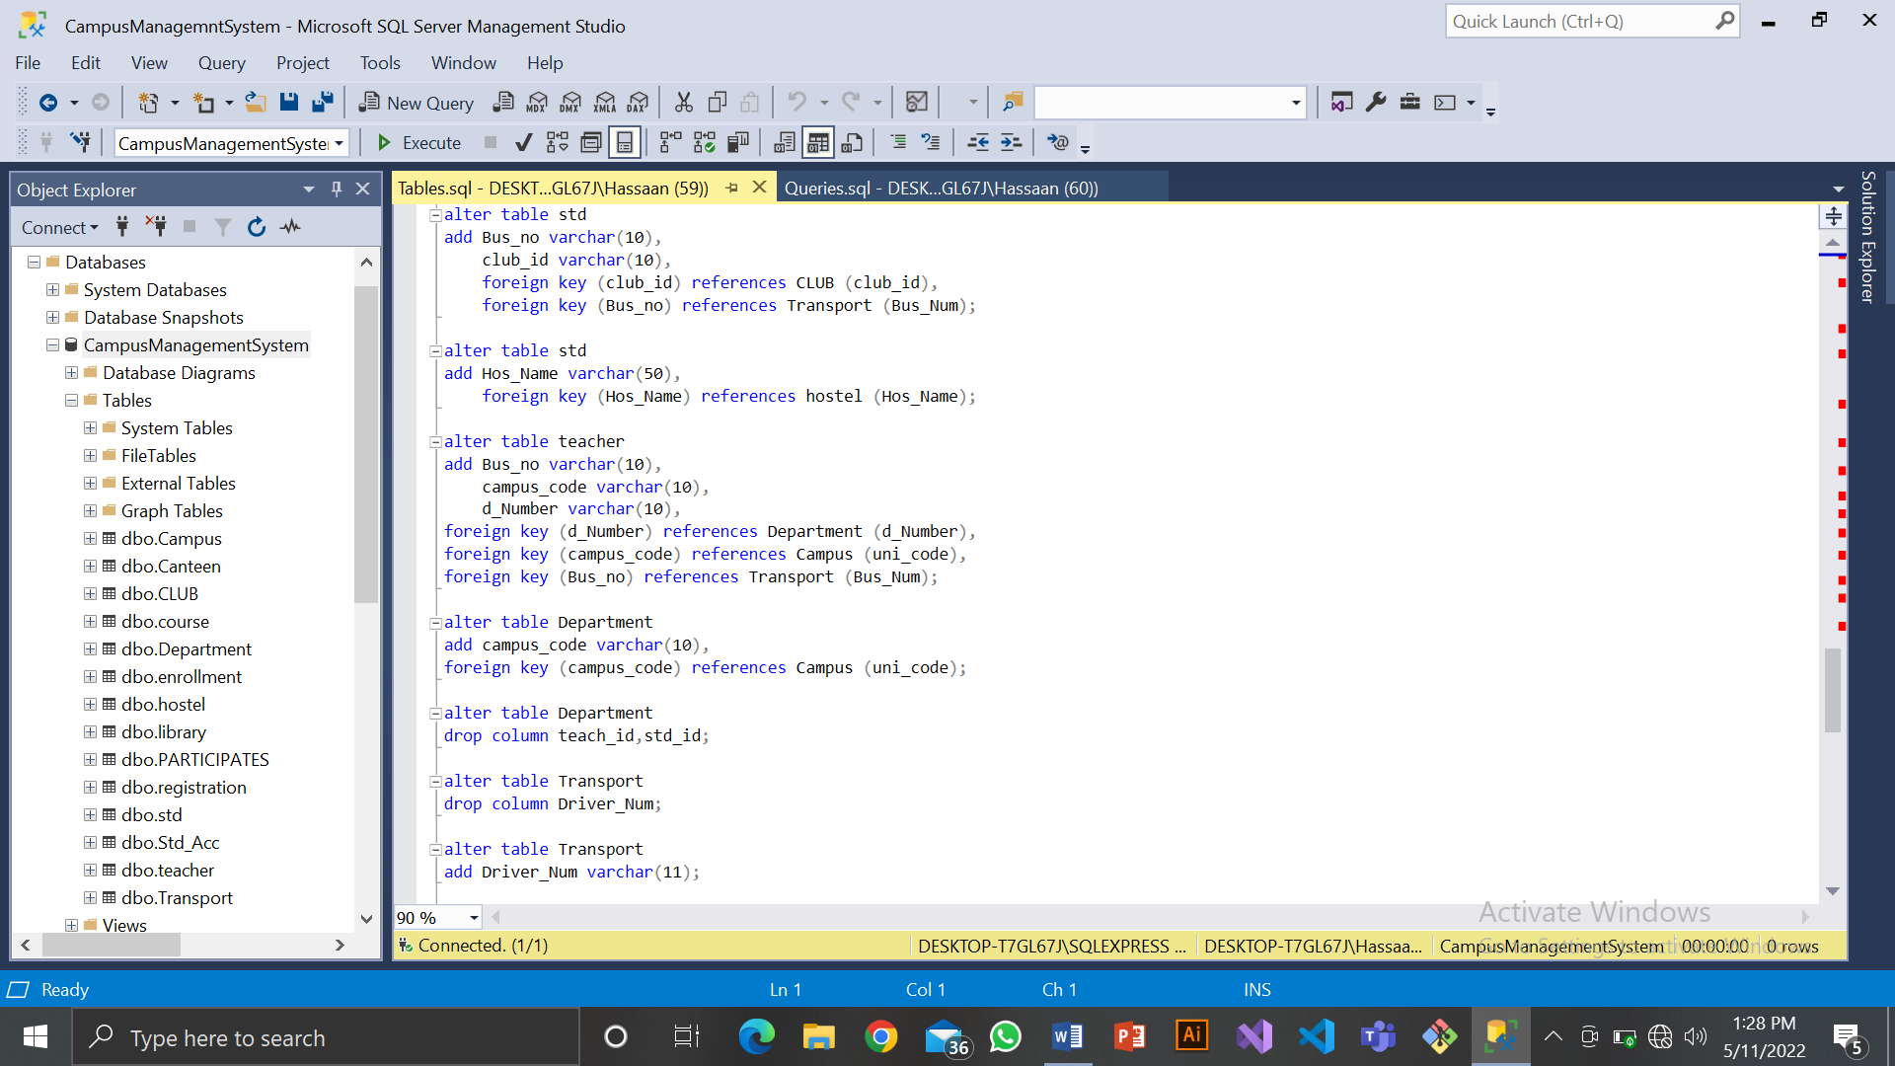

**Alter Table Command For Teacher Table**

* alter table teacher

add Bus_no varchar(10),

campus_code varchar(10),

d_Number varchar(10),

foreign key (d_Number) references Department (d_Number),

foreign key (campus_code) references Campus (uni_code),

foreign key (Bus_no) references Transport (Bus_Num);

add foreign key(cor_id)references corse(cor_id);

**OUTPUT SCREENSHOT**



**DATA MANIPULATION LANGUAGE**

**Insert Command For Department Table:**

insert into Department values

('A12e','CS','Mushtaq',01214),

('D15c','CE','Allah dita',01214),

('N11r','SE','Rizwan',01214),

('F62g','EE','Usman',01214),

('H19v','ME','Qasim',01522),

('Q11y','CE','Sunil',01522),

('B12e','Civil Engineering','Javed',03546),

('U82t','BBA','Shoiab',03546),

('C12c','BBIT','Danish',01095),

('X12z','Arts','Farukh',01095);

UPDATE Department

SET

d_Name = 'Maths'

WHERE

d_Number = 'D15c';

**OUTPUT SCREENSHOT**

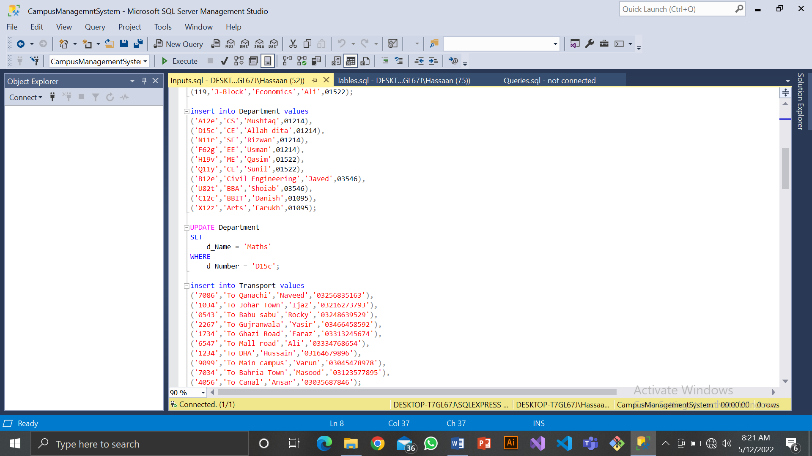

**Insert Command For Canteen Table:**

insert into Canteen values

(210,'A-Block','Biryani',100,01214),

(211,'B-Block','Burger',80,01522),

(212,'C-Block','Qorma',120,03546),

(213,'D-Block','Daal',40,01095),

(214,'E-Block','Shawarma',70,01522),

(215,'F-Block','Pizza',200,01214),

(216,'G-Block','Fruit Salad',50,01095),

(217,'H-Block','Fries',50,01522),

(218,'I-Block','Tea',30,01214),

(219,'J-Block','Coffee',90,01095)

;**OUTPUT SCREENSHOT**

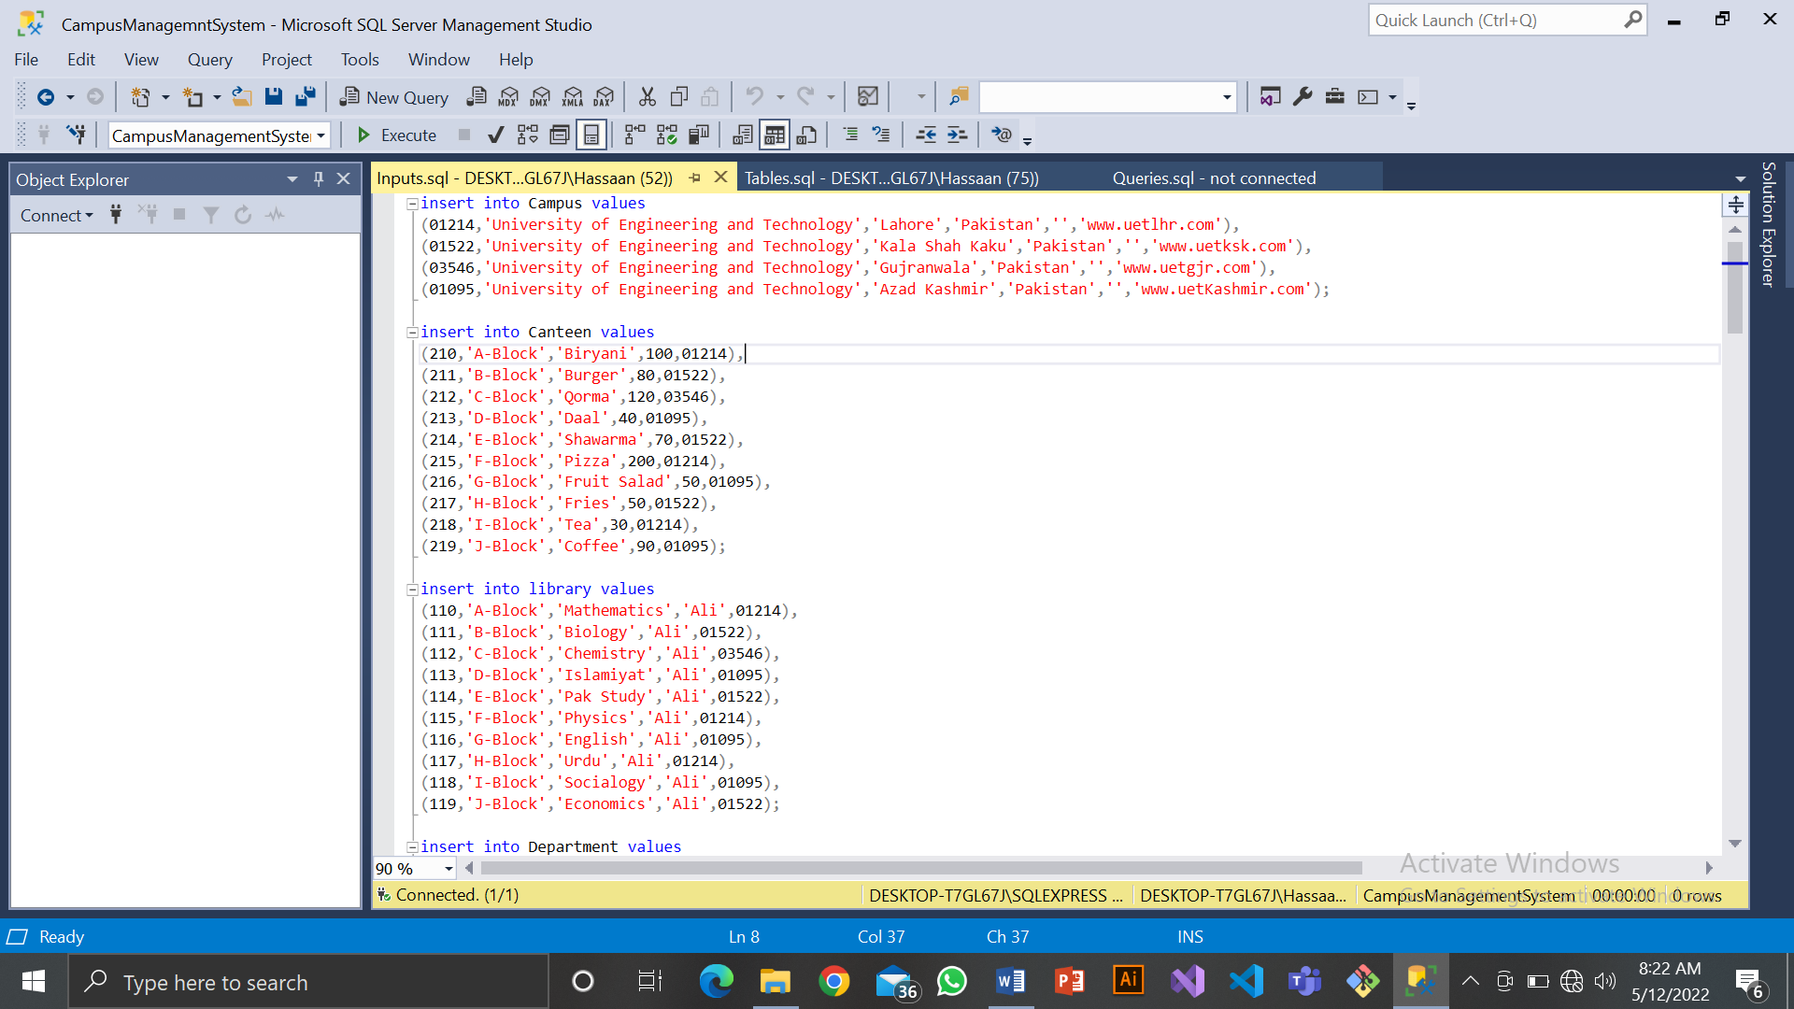

**Insert Command For Library Table:**

insert into library values

(110,'A-Block','Mathematics','Ali',01214),

(111,'B-Block','Biology','Ali',01522),

(112,'C-Block','Chemistry','Ali',03546),

(113,'D-Block','Islamiyat','Ali',01095),

(114,'E-Block','Pak Study','Ali',01522),

(115,'F-Block','Physics','Ali',01214),

(116,'G-Block','English','Ali',01095),

(117,'H-Block','Urdu','Ali',01214),

(118,'I-Block','Socialogy','Ali',01095),

(119,'J-Block','Economics','Ali',01522);

**OUTPUT SCREENSHOT**



**SELECT COMMANDS**

**Select Command For Campus:**

select * from campus

**OUTPUT SCREENSHOT**

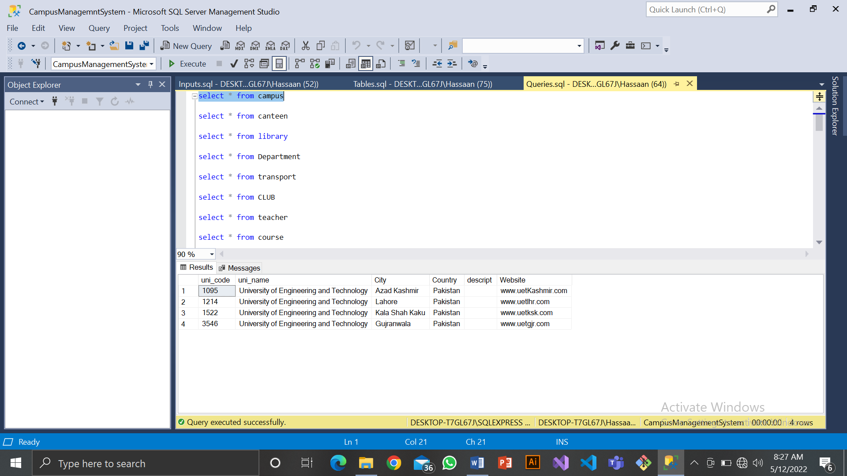

**Select Command For Teacher:**

select * from teacher

**OUTPUT SCREENSHOT**

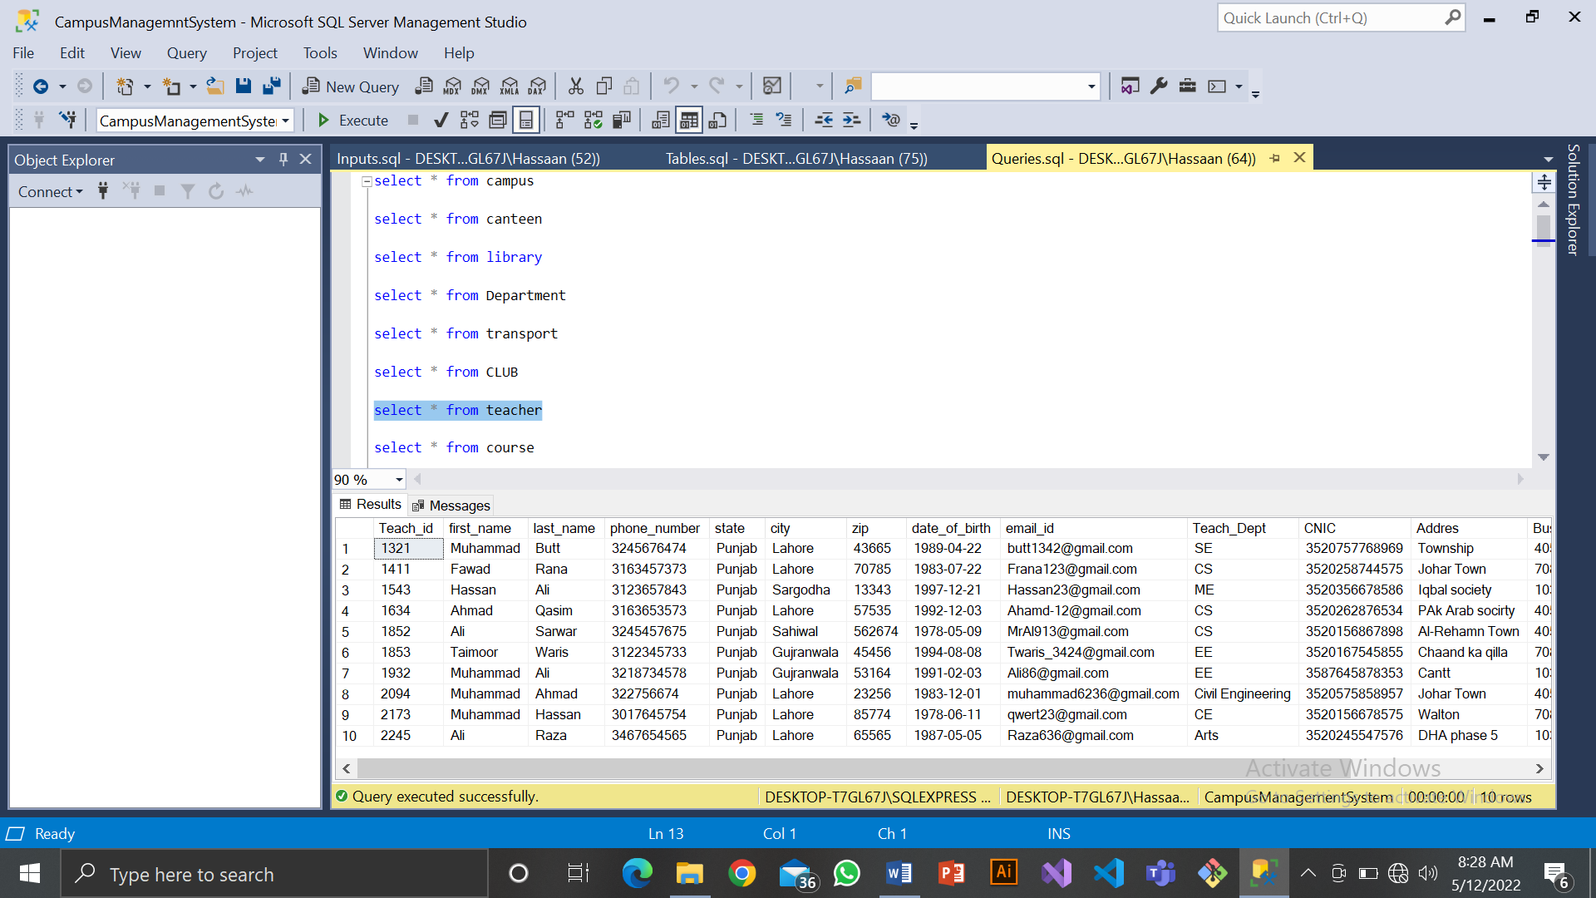

**Select Command For Transport:**

select * from transport

**OUTPUT SCREENSHOT**

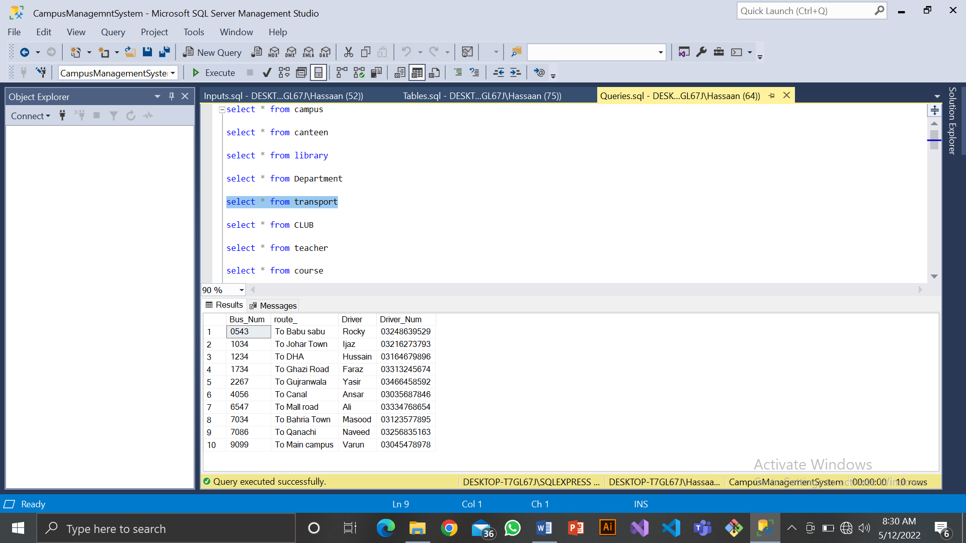

**Select Command For Department:**

select * from Department

**OUTPUT SCREENSHOT**

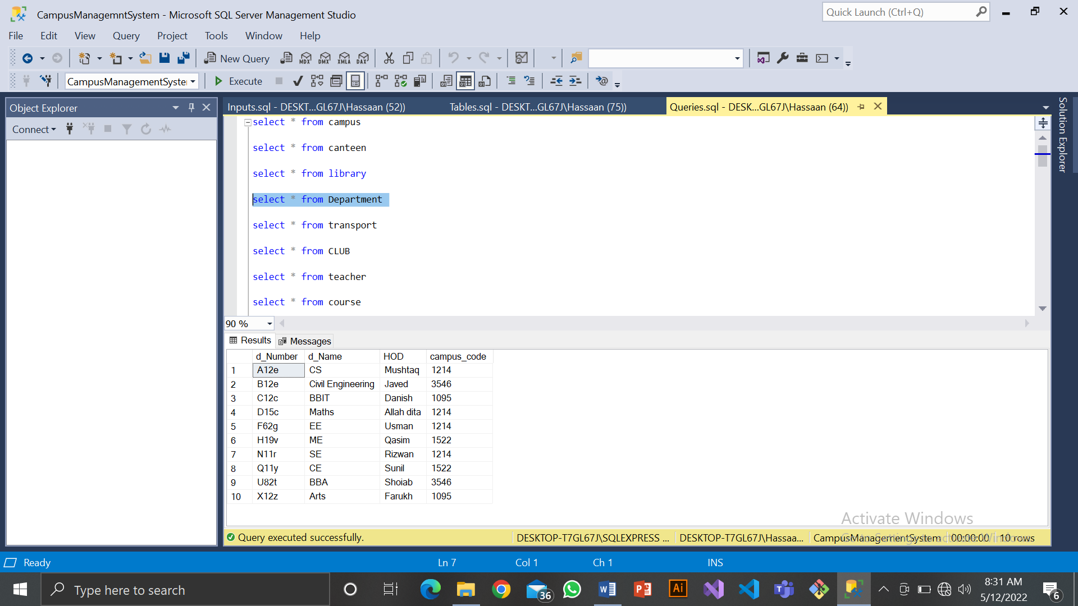

JOIN CONDITIONS

**INNER JOIN**

SELECT Teach_id,first_name,last_name

FROM teacher AS T

INNER JOIN Department AS D

ON T.d_Number = D.d_Number

**OUTPUT SCREENSHOT**

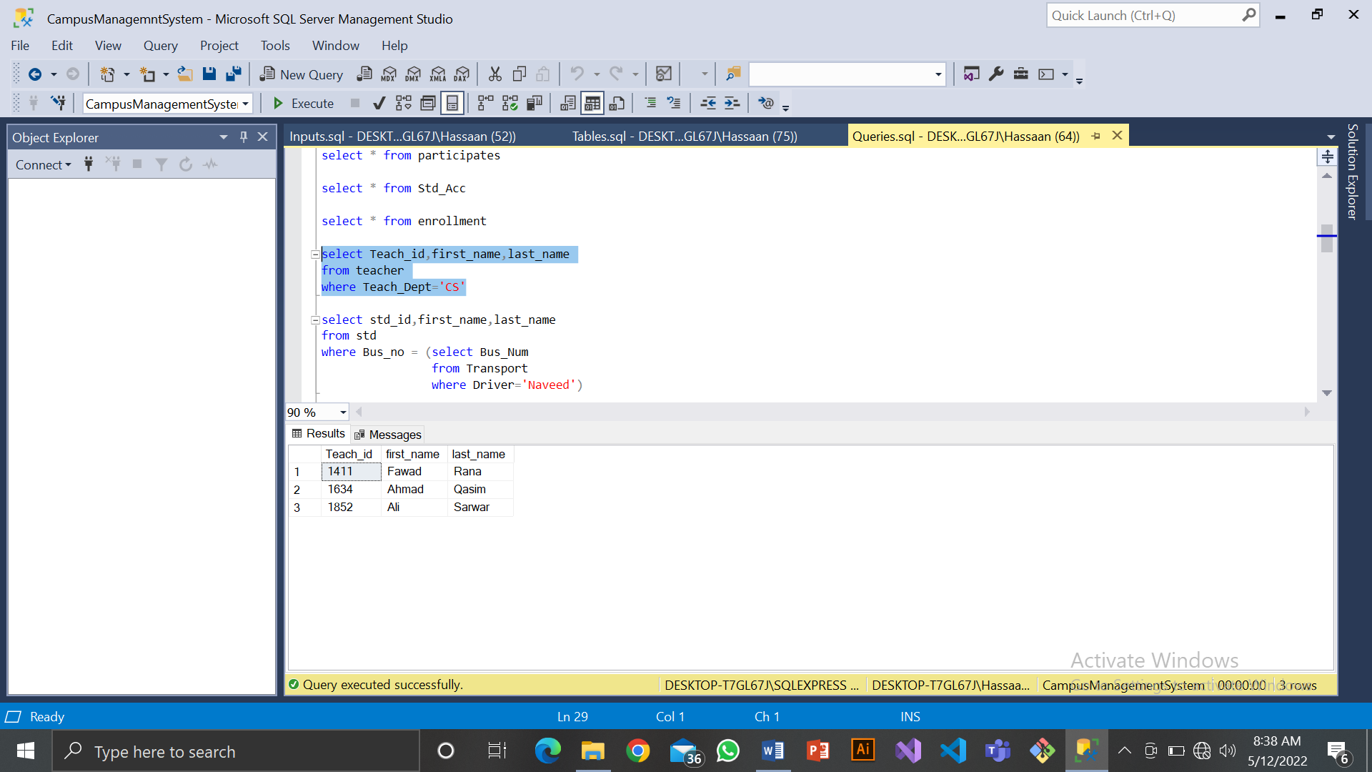

**LEFT JOIN**

SELECT d_Number,d_Name

FROM Department AS D

LEFT JOIN Campus AS C

ON D.campus_code=C.uni_code

**OUTPUT SCREENSHOT**

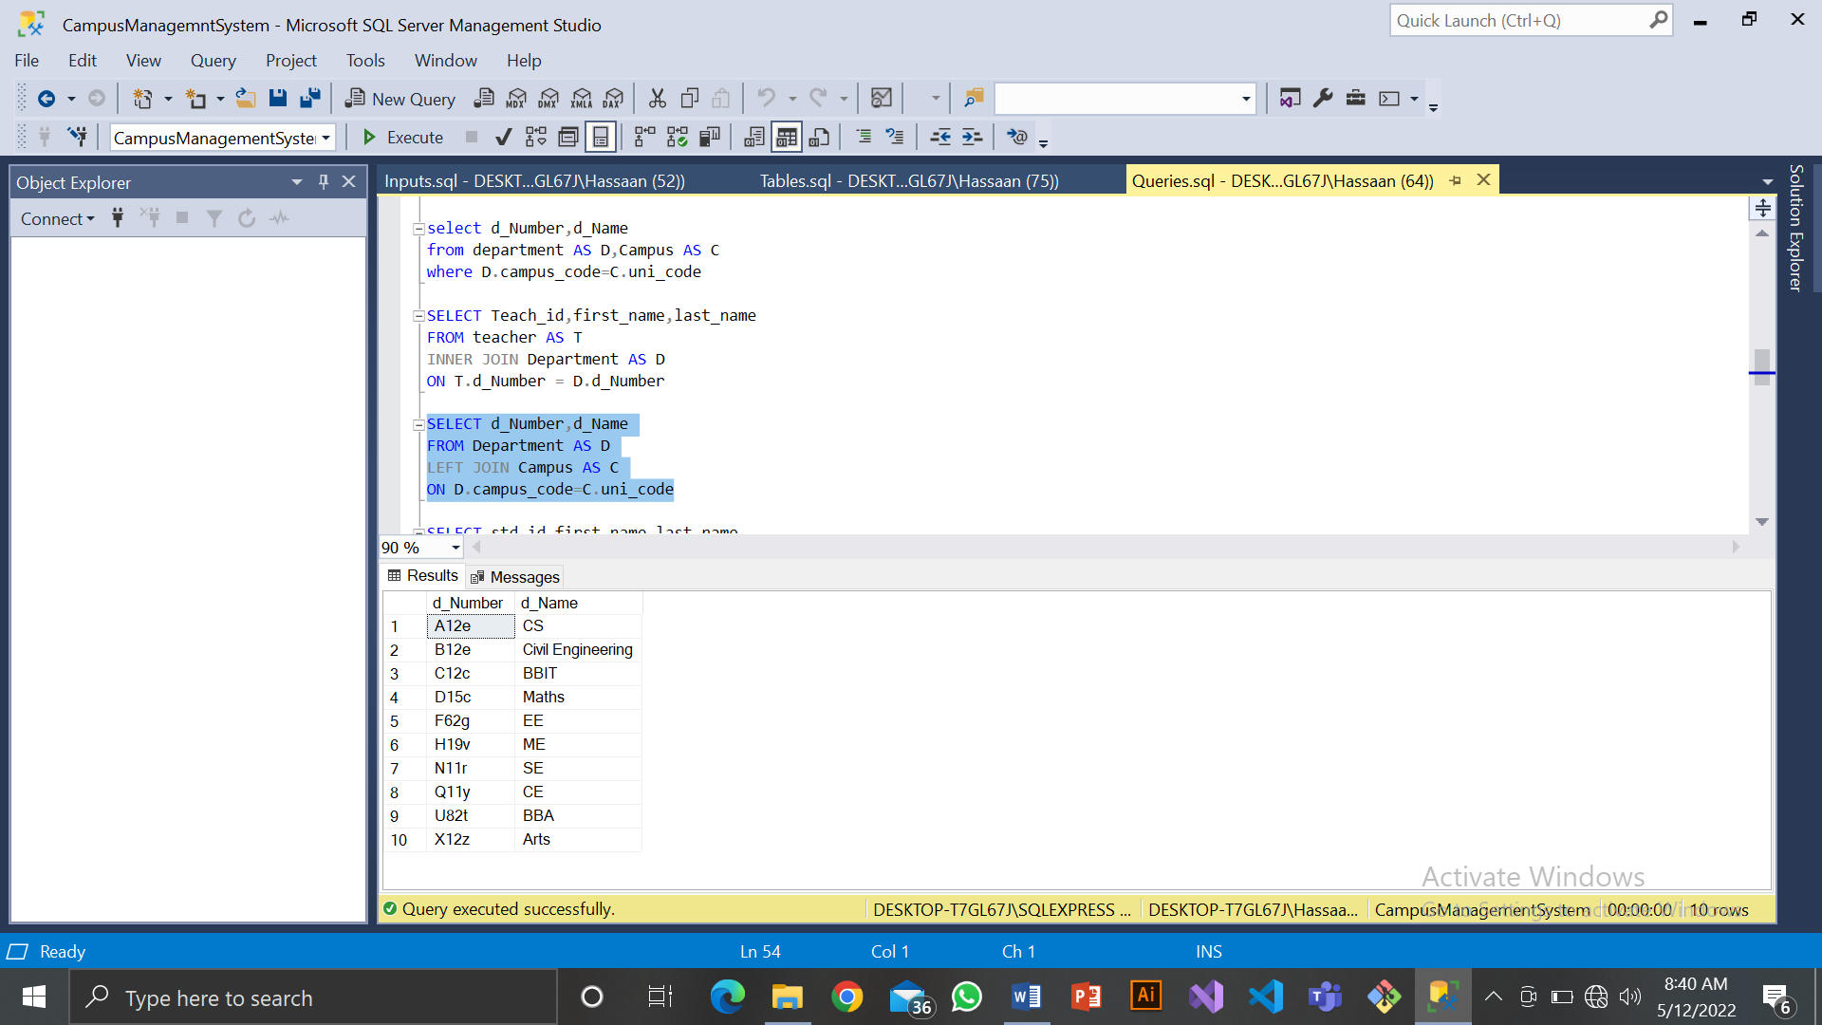

**RIGHT JOIN**

SELECT std_id,first_name,last_name

FROM std AS S

RIGHT JOIN Transport AS T

ON S.Bus_No = T.Bus_Num

**OUTPUT SCREENSHOT**

